
Dear IGALA members,
A very warm welcome to new members who have joined IGALA over the summer, and welcome back to our many long-standing members! I hope the new academic year has started well for you all.
It was great to see so many of you in Brazil this summer for the 7th IGALA conference. This was our first conference in South America and a huge success, in terms of new membership and bursaries offered to participants, but also in terms of engagement with important old and new debates. As the new IGALA President for the next two years, I’d like to take the opportunity once more to thank my predecessor, Ana Cristina Ostermann, for her invaluable contribution and commitment to the association. We have been very privileged indeed to have her (and to continue counting on her input as past-President for two more years), and we are very thankful to her and her team for making IGALA7 such a success. For those who missed the conference, please see http://www.unisinos.br/eventos/igala/.
From time to time, I’ll be posting IGALA news via this newsletter and the GALA-L list. Please contact me with any items, suggestions and ideas that are directly relevant to the association and its members. I’d also like to invite as many members as possible to participate in IGALA activities (more on which below), such as running for election, nominating others for election, putting in proposals for hosting a future IGALA conference, etc. Finally, I hope that you’ll get to know all the IGALA Executive Council and Advisory Board members (see below). It is a fantastic team and I look forward to working with them, to help make IGALA even more visible, even more diverse, and even more international.

Welcome

Lia Litosseliti

IGALA President

l.litosseliti@city.ac.uk
http://www.city.ac.uk/health/staff-directory/lia-litosseliti


Inside This Issue
1 Welcome
2 Current Executive Council & Advisory Board
3 Upcoming Elections
4 Gender and Language journal
4 IGALA Website
4 IGALA 8 conference (2014)

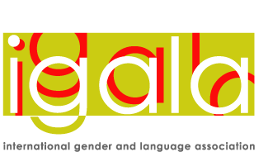Employee Newsletter

International Gender and Language Association
Newsletter, Issue 1, Sept 2012
IGALA Advisory Board and responsibilities:

Clare Anderson (University of Birmingham, UK) Graduate Student Representative
Mercedes Bengoechea (Universidad de Alcalá, Spain) Local IGALA branches
Carmen Rosa Caldas-Coulthard (University of Birmingham, UK) IGALA Book Prize
Holly Cashman (University of New Hampshire, USA) Communications & Media; NSF grants
Grace Diabah (University of Ghana / Lancaster University) IGALA Bursaries liaison
Laurel Kamada (Tohoku University, Japan) Elections; IGALA bursaries liaison
Brian King (City University of Hong Kong) Gender & Language journal liaison
Joana Plaza Pinto (Federal University of Goiás, Brazil) Communications & Media; assisting with IGALA membership

Maryam Paknahad Jabarooty, Webweaver

IGALA would like to thank previous advisory board members Ann Weatherall, Allyson Jule and Jenny Davies for their contribution; and others who have acted in an advisory capacity in recent years: Mary Bucholtz (NSF grants applicant) and Jane Sunderland (guardian of bursaries)

Current Executive Council & Advisory Board


IGALA7 conference team members, UNISINOS, Brazil (with Ana Cristina Ostermann, in the centre)
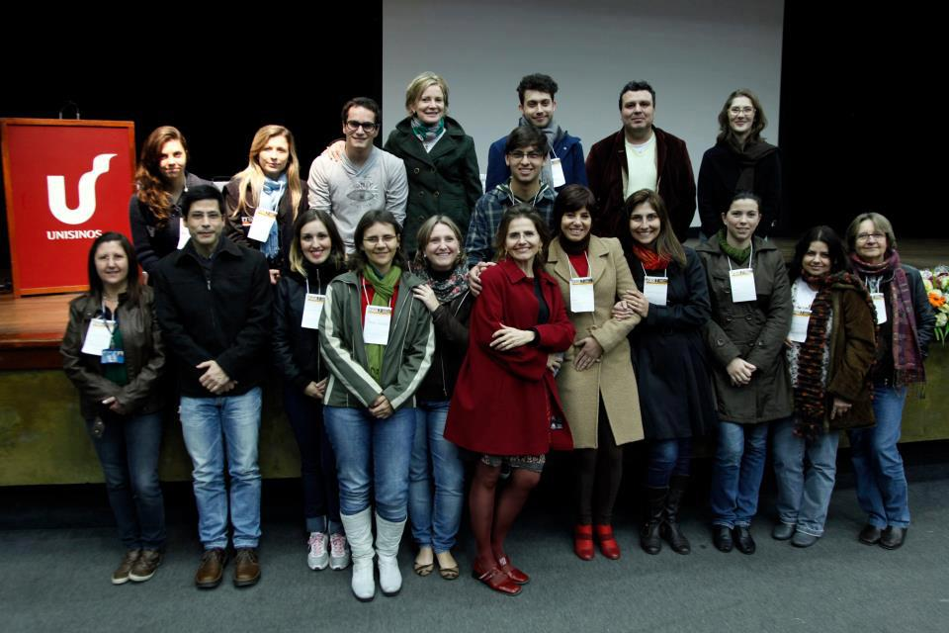
IGALA Executive Council:
__________________________
President: Lia Litosseliti (City University London, UK)

Secretary: Michelle Lazar (National University of Singapore)

Vice-President/ President Elect: [elections open (2012) to replace Lia Litosseliti]

__________________________
Past President: Ana Cristina Ostermann (UNISINOS, Brazil)
Members (including some current Executive & Advisory members) during IGALA 7

Upcoming Elections
IGALA is now calling for nominations for two Executive Council posts, to run for 2 years:
~ Vice-President / President-Elect
~ Secretary
NOMINATIONS OPEN: 1 Oct -1 Nov 2012
CLOSING DATE FOR NOMINATIONS: 1 November, 2012
ELECTIONS will run from 5 November through 5 December, 2012
IMPORTANT STIPULATIONS: ONLY paid up members can nominate someone. ONLY paid up members can be nominated. You may nominate yourself.
If you are interested in nominating a person (including yourself) who is NOT yet an IGALA member, you (and they) have until elections begin (Nov. 5) to join IGALA. To join IGALA (which includes subscription to the journal Gender and Language), please go to: http://www.equinoxjournals.com/index.php/GL/about/subscriptions
IN ORDER TO NOMINATE:
*Include: your name, nominee’s name, position nominated for, and nominee’s e-mail address.
* Please send your nomination for Vice-President/ President-Elect to Lia Litosseliti, IGALA President, at l.litosseliti@city.ac.uk , ensuring your message subject is 'IGALA Nomination for VP'
* Please send your nomination for Secretary to Michelle Lazar at ellmml@nus.edu.sg, ensuring your message subject is 'IGALA Nomination for Secretary'
Duties
1. The Vice-President/President-Elect is responsible for:
supporting the President as appropriate in all the President’s duties; assuming the duties of the President in the event the President cannot serve, and succeeding to the office of President* at the expiration of the term as President-elect; monitoring the IGALA site, identifying new links/ documents/ information to be posted on it, and liaising with the Webweaver about this (together with the President and Secretary); chairing the Nominations Committee for Advisory and Executive committee members; running the IGALA (Post)graduate Student Essay Competition (including chairing the committee, one member of whom will be the Graduate Student Representative)
2. The Secretary is responsible for
gathering agenda items for meetings; producing and distributing agendas; keeping Minutes of IGALA Executive and Open meetings; maintaining records of meetings and decisions; producing and distributing/posting Minutes of the meetings to the IGALA Membership; in conjunction with the Vice President/President-elect, organising elections and distributing/posting results to members ; monitoring the IGALA site, identifying new links, documents and information to be posted on it, and liaising with the Webweaver about this (together with the President and President-elect)
*The President is responsible for
working for a policy that balances the needs of members with service to gender and language study; representing IGALA and speaking on its behalf, including in a lobbying capacity; working to develop relations between IGALA and other academic/professional/political bodies; consulting with Executives on IGALA management issues and deciding on these issues on the basis of Executive's wishes; ensuring that Executives have regular e-discussions on IGALA issues; ensuring that the IGALA conference takes place and liaising with the organiser; chairing (a) an Executive meeting, and (b) an Open Business meeting at the IGALA conference; ensuring that decisions are followed through (with the Secretary); drawing up the Agenda for Executive Meetings (with the Secretary) and running the meetings; maintaining links with the editors of the Gender and Language journal; monitoring the IGALA site (with the VP and Secretary)
We are looking forward to your nominations!
If you have seen the messages on the list by the Gender and Language journal editors (Liz Stokoe and Ann Weatherall), you will know that the journal is going from strength to strength. Developments include an increase to three issues per year from 2013, and an early view/online first system, such that accepted articles will be published online, with a DOI, as they become ready. The new issue of Gender and Language, Volume 6 Issue 2, is now available online:
http://www.equinoxpub.com/GL
Please remember that IGALA membership includes a subscription to the journal. You can join IGALA as a regular member from the Equinox website by going to the subscription pages and choosing IGALA membership.

Gender and Language Journal
Our next international conference, IGALA 8, will be held on 5-7 June 2014, at Simon Fraser University, Harbour Centre, in Vancouver, British Columbia, Canada. The conference is being organised by Allyson Jule (Trinity Western University) and Sandra McGoldrick (University of British Columbia) and promises to be a great event – with Bonny Norton, Marjorie Goodwin, and Jane Sunderland as confirmed speakers. Please watch for announcements via the GALA-L list.
In 2013, we will be inviting proposals from members (to be presented in Vancouver) for hosting the next/future IGALA conferences. We strongly encourage members to consider hosting a future conference, and looking forward to hearing your ideas in due time!
In the meantime, we have a terrific destination to look forward to in 2014: http://www.youtube.com/watch?v=lIAYPopVBXM

Warm regards to all,
from the IGALA team

IGALA 8 Conference (2014)

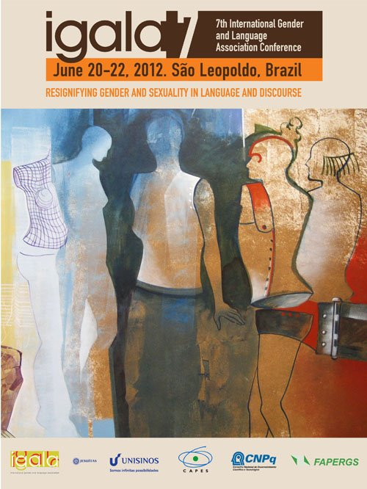IGALA 7 Conference poster

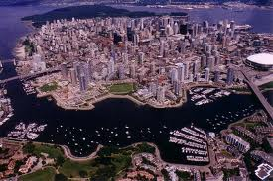
IGALA 8 Conference location

IGALA Website
Please bear with us while the IGALA website is under construction. We will contact members when it is complete. We will also be inviting your views soon on the best use of the website, and indeed of the Association, for its members.

complete, and i

